

PROPOSAL DOCUMENT

Scoping Document for the Provision of
Penetration Testing

Labournet (Pty) Ltd

24 October 2025

Prepared by Sautech (Pty) Ltd

TABLE OF CONTENTS

1 Executive summary 4
2 RFQ ALIGNMENT (Scope confirmation) 4
3 Objectives AND BUSINESS OUTCOMES 4
4 COMPANY PROFILE – WHY SAUTECH 4
5 GOVERNANCE, COMPLIANCE & ASSURANCE 4
6 DETAILED SCOPE 4
6.1 In-Scope 4
6.2 Out of Scope 5
6.3 Assumption and Constraints 5
7 Methodologies AND TEST PHASES 5
8 7-DAY SCHEDULE (DETAILED) 5
9 TOOLS & TEQNIQUES (FULL LIST AND PURPOSE) 6
9.1 Fortigate Testing Details and Safety Controls 6
9.2 Web Application Testing Approach 6
9.3 Network & Infrastructure Testing Approach 6
9.4 Wi-Fi Testing Approach 6
9.5 Phishing and Social Engineering Plan (10 users) 7
10 Methodologies / TechnologIES EXPLAINED 7
10.1 Nmap / Zenmap 7
10.2 Nessus 7
10.3 Greenbone Enterprise 7
10.4 Kali Linux 8
10.5 Hydra / Brute Force 9
10.6 OWASP 9
STAY ONE STEP AHEAD OF ATTACKERS 10
11 Examples of Attack and results 10
11.1 Vulnerability Scan 10
11.2 Brute Force 11
11.3 Port Mapping 11
11.4 Web Application Testing 12
11.5 Database Exploitation 12
11.6 Active Directory 12
11.7 Wireless Network 13
12 REPORTING AND REMEDIATION DELIVERABLES 13
13 COSTING AND COMMERCIALS 13
14 Risk Analysis for Cyber Penetration Testing Proposal 14
14.1 Objective 14
14.2 Risk Identification 14
14.3 Risk Assessment 15
14.4 Risk Mitigation 15
14.5 Risk Monitoring and Review 15
15 TERMS & CONDITIONS 16
15.1 Confidentiality 16
15.2 Client Responsibilities 16
15.3 Testing Boundaries 16
15.4 Liability 16
15.5 Compliance 16
15.6 Reporting and Ownership 16
15.7 Payment Terms 16
15.8 Validity 16
16 References / APENDICES 16
17 CONCLUSION 17
18 AUTHORISATION 17

Executive summary

This proposal responds to the RFQ Scoping Document dated 01/11/2025. Sautech proposes a controlled, authorized Black-Box penetration test covering the client’s internal infrastructure (3–5 IPs), web applications (Vaadin, Laravel, Spring Boot microservices), nine Ubiquiti UniFi access points (2 SSIDs), and FortiGate firewall resilience testing. The engagement is a 7-day active test plus optional retest. Deliverables include Executive Summary, Technical Report, FortiGate findings, Wi-Fi report, phishing metrics, and a remediation workshop.

RFQ ALIGNMENT (Scope confirmation)

Sautech confirms the scope as described in your Scoping Document: Internal infrastructure testing, network penetration testing, three web applications, Wi-Fi assessment of nine Ubiquiti UniFi APs and two SSIDs, and FortiGate DoS/DDoS resilience testing. Testing will be performed in production (as requested) with signed Rules of Engagement (RoE). Phishing/social engineering is INCLUDED for a 10-user cohort (2 executives, 2 new staff, 6 mid-level).

Objectives AND BUSINESS OUTCOMES

- Identify exploitable vulnerabilities and demonstrate real-world impact through controlled proof-of-concepts.
- Validate and harden FortiGate DoS/IPS policies and logging for improved SOC detection.
- Measure user susceptibility to phishing and provide tailored awareness training.
- Provide actionable remediation steps and optional retest verification.

COMPANY PROFILE – WHY SAUTECH

Sautech (Pty) Ltd is a South African IT security and hosting company with over 20 years of experience in managed hosting, disaster recovery and cybersecurity. We operate in multiple regional data centers (in South Africa and Namibia), and offer local expertise, rapid on-ground support, and a deep understanding of regional regulatory requirements such as POPIA. We combine penetration testing expertise with practical remediation support and optional managed services to ensure fixes are implemented effectively.

GOVERNANCE, COMPLIANCE & ASSURANCE

Our testing methodology maps to international standards: OWASP Top 10 for web apps, NIST SP 800-115 for testing processes, and ISO/IEC 27001 controls for governance. Reports will include CVSS scoring and mapping to compliance requirements.

DETAILED SCOPE

In-Scope

- Internal infrastructure (3–5 IP addresses provided by client)
- Network pentest (LAN, VLAN segmentation, routing, firewall rules)
- Web applications x3: Vaadin monolith (Java), Laravel (PHP LAMP), Spring Boot microservices (Java)
- Wi-Fi: Nine Ubiquiti UniFi APs; two SSIDs
- FortiGate firewall: configuration review and controlled DoS/DDoS resilience testing
- Phishing & social engineering: simulated email campaign (10 users)

Out of Scope

- External infrastructure beyond supplied IPs
- Source code review (optional add-on)
- Physical security testing
- Any destructive testing causing data loss without explicit prior approval

Assumption and Constraints

- Client will supply asset lists, 3–5 IPs, application URLs, and test accounts prior to Day
- Testing in production is authorized; client has up-to-date backups.
- Client will provide emergency contacts and agree test windows.
- Any additional scope (extra apps, external infra) will be re-quoted and require additional authorization.

Methodologies AND TEST PHASES

We apply a seven-phase methodology adapted to a 7-day engagement:

- Kickoff & RoE
- Reconnaissance & discovery
- Vulnerability analysis (automated + manual)
- Exploitation & proof-of-concept
- Post-exploitation & privilege escalation (as authorized)
- Phishing campaign execution & monitoring
- Reporting, remediation workshop & optional retest

7-DAY SCHEDULE (DETAILED)

Day 1 — Project kickoff & Reconnaissance:
• Sign RoE, confirm assets, obtain credentials and contact list.
• Passive OSINT, DNS/subdomain enumeration, light scans.
Day 2 — Discovery & Scanning:
• Active host/service discovery (nmap, masscan), web endpoint mapping (ffuf/gobuster).
• Initial automated web scans (Burp, Nikto), Wi-Fi passive survey.
Day 3 — Vulnerability Analysis:
• Manual verification of automated findings; deep app testing (auth, session, input validation).
• AD/Windows enumeration (Responder, CrackMapExec) if present.
Day 4 — Exploitation & PoC:
• Controlled exploitation of validated vulnerabilities; privilege escalation and lateral movement tests where authorized.
Day 5 — FortiGate Resilience Tests & Wi-Fi Active Testing:
• Incremental FortiGate tests (hping3, nping, tcpreplay) with thresholds; Wi-Fi active tests (handshake capture, rogue AP sim).
Day 6 — Phishing Campaign Execution & Monitoring:
• Launch Gophish campaign to 10 users; monitor opens/clicks and simulated credential submissions; provide on-the-spot coaching for reported incidents.
Day 7 — Evidence Consolidation & Reporting Workshop:
• Deliver Executive Summary and Technical Report; conduct 60–90 minute remediation workshop. Agree retest scope.

TOOLS & TEQNIQUES (FULL LIST AND PURPOSE)

All testing will be performed using reputable tools available in Kali Linux and commercial suites. Tools are selected per task to minimize false positives and maximize defensible findings.
Key tools:
- Reconnaissance: nmap, masscan, Amass, theHarvester, dnsenum, dnsrecon, crt.sh
- Web Application Testing: Burp Suite (Pro), sqlmap, ffuf, gobuster, Nikto, OWASP ZAP, Postman, LinkFinder
- Authentication & AD: Hydra, Responder, Impacket (wmiexec, secretsdump), CrackMapExec, BloodHound, Mimikatz (with approval)
- Network Exploitation: Metasploit, Netcat, Socat, proxychains, tcpdump, Wireshark
- Wi-Fi: aircrack-ng suite, wifite, bettercap, hostapd-wpe (consent), Kismet
- FortiGate DoS/Resilience: hping3, nping, tcpreplay, custom Scapy scripts, slow HTTP tools (rate-limited)
- Phishing: Gophish (self-hosted), custom landing pages, phishing analytics scripts

Fortigate Testing Details and Safety Controls

Test Types:
• State table exhaustion (SYN half-open tests)
• Connection churn & session flood tests
• Application-layer slow attacks (limited slow HTTP)
• IPS/NGFW signature validation and tuning
• HA failover observation under controlled load
Safety Controls:
• Agreed thresholds and incremental testing phases
• Real-time monitoring with client technical contact
• Immediate halt on service degradation
• No use of public botnets or uncontrolled external sources

Web Application Testing Approach

For each of the three applications we will perform authenticated and unauthenticated testing (where credentials are provided) covering:
• Authentication and session management
• Input validation and injection attacks (SQLi, XSS, CSRF)
• Authorization checks and business logic flaws
• File upload handling, insecure deserialization, token handling
• Microservice inter-communication and API authentication (for Spring Boot microservices)

Network & Infrastructure Testing Approach

We will perform host enumeration, service/version detection, configuration checks, firewall policy validation, VLAN segmentation tests, and controlled lateral movement tests using Impacket/CrackMapExec and BloodHound to map potential attack paths.

Wi-Fi Testing Approach

Passive discovery and active (consented) tests including handshake capture for WPA/WPA2, testing for weak PSKs, rogue AP deployment in a controlled lab mode, client isolation checks and UniFi controller security review.

Phishing and Social Engineering Plan (10 users)

Target cohort: 10 users — 2 executives, 2 new staff, 6 mid-level.
Objectives:
• Measure click-through and credential submission rates
• Test attachment opening and behavior
• Test reporting behaviour to IT/security
Execution:
• Up to 3 realistic phishing templates (invoice, IT password reset, corporate announcement)
• Gophish self-hosted campaign with link tracking and safe credential capture (placeholders only)
• Immediate user coaching and tailored awareness materials for users who fall for the test
Privacy/HR:
• Client must provide consent and HR approval; results handled confidentially and used only for remediation and training.

Methodologies / TechnologIES EXPLAINED

Sautech will apply a combination of automated and manual audit techniques to thoroughly evaluate Labournet’s systems. These methodologies are designed to identify, exploit, and validate vulnerabilities while ensuring compliance with PSD-12, OWASP, and international security standards. The techniques include the following:

Nmap / Zenmap

Port scanning, network mapping, identification of open ports and misconfigurations.
Nmap, short for Network Mapper, is a tool used for vulnerability checking, port scanning and, of course, network mapping. Despite being created back in 1997, Nmap remains the gold standard against which all other similar tools either commercial or open source, are judged.

To deploy Nmap, users originally had to have some advanced programming skills, with the introduction of the Zenmap tool for Nmap, which adds a graphical interface that makes launching the program and analysing the returned output it generates much more accessible.

Nessus

Comprehensive vulnerability scanning with 1200+ checks for known exploits Nessus is a remote security scanning tool, which scans a computer and raises an alert if it discovers any vulnerabilities that malicious hackers could use to gain access to any computer you have connected to a network. It does this by running over 1200 checks on a given computer, testing to see if any of these attacks could be used to break into the computer or otherwise harm it.

Greenbone Enterprise
Automated vulnerability management and compliance reporting. Greenbone is the world’s most widely used vulnerability management provider.
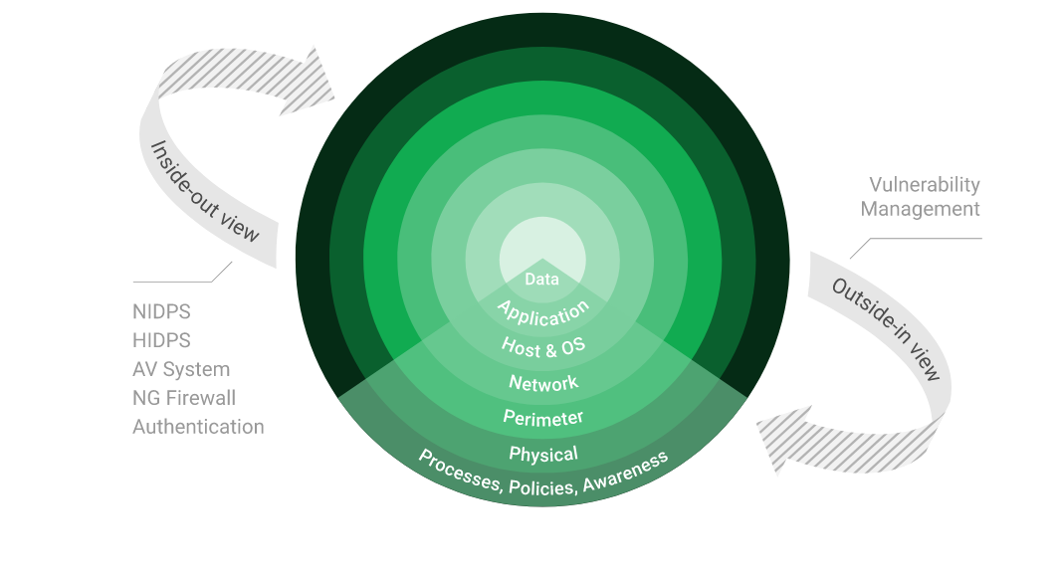

Kali Linux

Exploitation framework including Hydra, Crunch, CUpp for brute force and attack simulations.
- Kali Linux (formerly known as BackTrack Linux) is an open-source, Debian-based Linux distribution aimed at advanced Penetration Testing and Security Auditing. It does this by providing common tools, configurations, and automations which allows the user to focus on the task that needs to be completed, not the surrounding activity.
- Kali Linux contains industry specific modifications as well as several hundred tools targeted towards various Information Security tasks, such as Penetration Testing, Security Research, Computer Forensics, Reverse Engineering, Vulnerability Management and Red Team Testing.
- Kali Linux is a multi-platform solution, accessible and freely available to information security professionals and hobbyists.
- Kali Linux Features: more than 600 penetration testing tools included. After reviewing every tool that was included in BackTrack, we eliminated a great number of tools that either simply did not work or which duplicated other tools that provided the same or similar functionality. Details on what’s included are on the Kali Tools site.
- Free (as in beer) and always will be: Kali Linux, like BackTrack, is completely free of charge and always will be. You will never, ever have to pay for Kali Linux.
- Open source Git tree: We are committed to the open source development model and our development tree is available for all to see. All of the source code which goes into Kali Linux is available for anyone who wants to tweak or rebuild packages to suit their specific needs.
- FHS compliant: Kali adheres to the Filesystem Hierarchy Standard, allowing Linux users to easily locate binaries, support files, libraries, etc.
- Wide-ranging wireless device support: A regular sticking point with Linux distributions has been support for wireless interfaces. We have built Kali Linux to support as many wireless devices as we possibly can, allowing it to run properly on a wide variety of hardware and making it compatible with numerous USB and other wireless devices.
- Custom kernel, patched for injection: As penetration testers, the development team often needs to do wireless assessments, so our kernel has the latest injection patches included.
- Developed in a secure environment: The Kali Linux team is made up of a small group of individuals who are the only ones trusted to commit packages and interact with the repositories, all of which is done using multiple secure protocols.
- GPG signed packages and repositories: Every package in Kali Linux is signed by each individual developer who built and committed it, and the repositories subsequently sign the packages as well.
- Multi-language support: Although penetration tools tend to be written in English, we have ensured that Kali includes true multilingual support, allowing more users to operate in their native language and locate the tools they need for the job.
- Completely customizable: We thoroughly understand that not everyone will agree with our design decisions, so we have made it as easy as possible for our more adventurous users to customize Kali Linux to their liking, all the way down to the kernel.
- ARMEL and ARMHF support: Since ARM-based single-board systems like the Raspberry Pi and BeagleBone Black, among others, are becoming more and more prevalent and inexpensive, we knew that Kali’s ARM support would need to be as robust as we could manage, with fully working installations for both ARMEL and ARMHF systems. Kali Linux is available on a wide range of ARM devices and has ARM repositories integrated with the mainline distribution so tools for ARM are updated in conjunction with the rest of the distribution.
- Kali Linux is specifically tailored to the needs of penetration testing professionals, and therefore all documentation on this site assumes prior knowledge of, and familiarity with, the Linux operating system in general.

Hydra / Brute Force

Used to simulate brute force attacks against authentication portals (SSH, RDP, web logins).
- A brute force attack is a hacking method that uses trial and error to crack passwords, login credentials, and encryption keys. It is a simple yet reliable tactic for gaining unauthorized access to individual accounts and organizations’ systems and networks. The hacker tries multiple usernames and passwords, often using a computer to test a wide range of combinations, until they find the correct login information.
- The name "brute force" comes from attackers using excessively forceful attempts to gain access to user accounts. Despite being an old cyberattack method, brute force attacks are tried and tested and remain a popular tactic with hackers

4.5.1 Applications in Brute Force Include:
Hydra is a parallelized network login cracker built in various operating systems like Kali Linux, Parrot and other major penetration testing environments. Hydra works by using different approaches to perform brute-force attacks in order to guess the right username and password combination. Hydra is commonly used by penetration testers together with a set of programmes like crunch,[2] cupp[3] etc, which are used to generate wordlists. Hydra is then used to test the attacks using the wordlists that these programmes created.

Over 1 Million + Username and password combos are used to Brute force application like RDP, SSH etc.

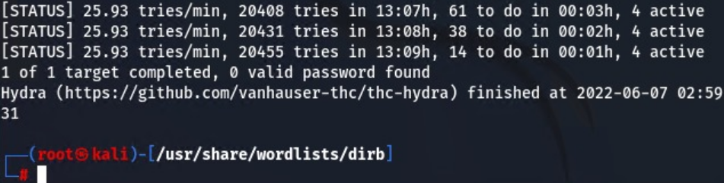

OWASP

Framework for identifying web application vulnerabilities (SQLi, XSS, CSRF, authentication flaws).

The Open Web Application Security Project (OWASP) is an online community that produces freely-available articles, methodologies, documentation, tools, and technologies in the field of web application security. The Open Web Application Security Project (OWASP) provides free and open resources. It is led by a non-profit called The OWASP Foundation. The OWASP Top 10 - 2021 is the published result of recent research based on comprehensive data compiled from over 40 partner organizations.

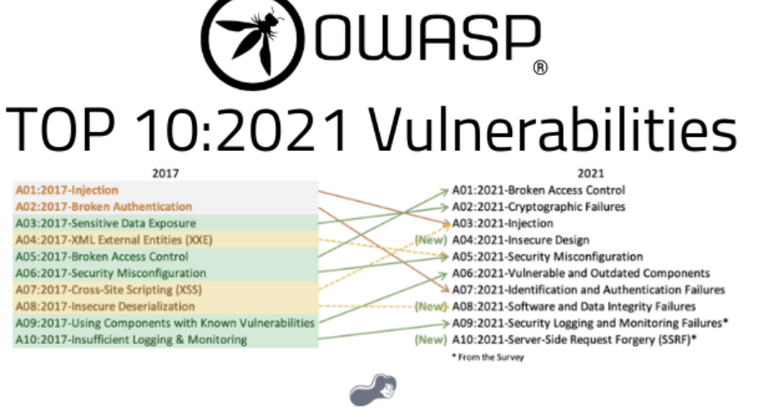

STAY ONE STEP AHEAD OF ATTACKERS

IT security is a process – Open Source vulnerability management provides the foundation. Once you know where the chinks are in your armor, you can do something about them.

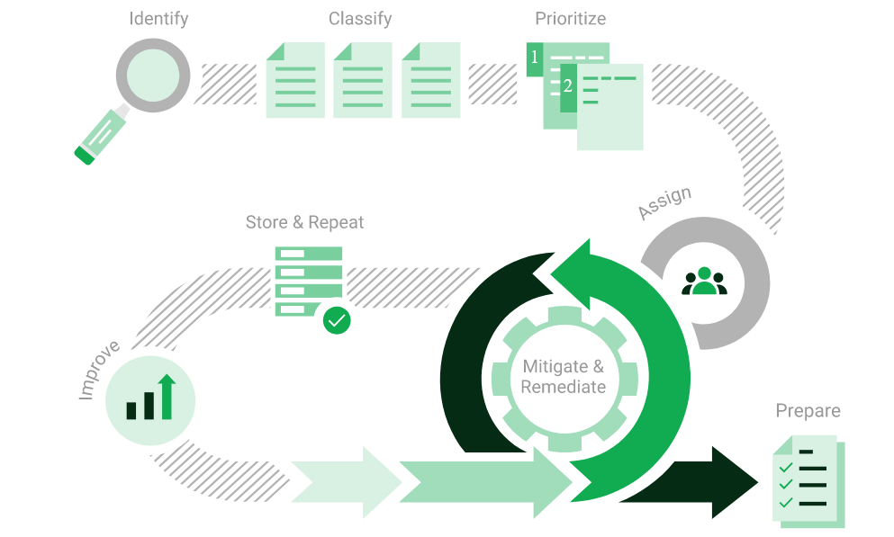

The process – from recognition to remedy and monitoring – represents a continuous cycle. You’ll always be one step ahead of attackers.

Examples of Attack and results

Vulnerability Scan

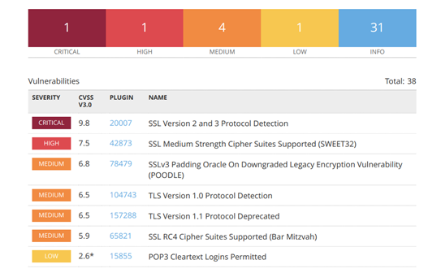

Brute Force

Testing authentication portals using Hydra with large-scale wordlists.
Randomised usernames with a word list containing more than 1+ million words and common passwords were brute forced SSH’s onto the server using Hydra.

Hydra works by using different approaches to perform brute-force attacks in order to guess the right username and password combination. Hydra is commonly used by penetration testers together with a set of programmes like crunch, cupp etc, which are used to generate wordlists.

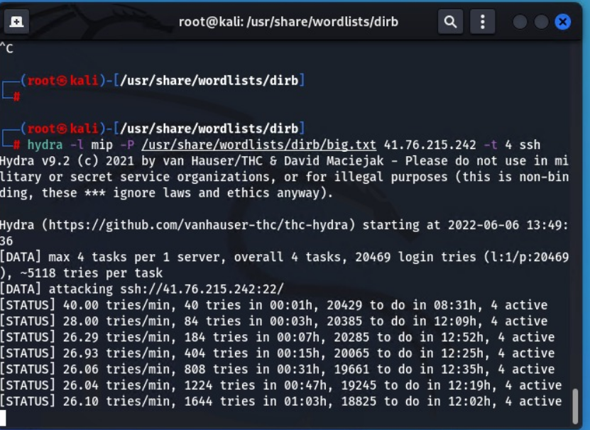

Port Mapping

Using Nmap to identify open ports, misconfigurations, and potential attack vectors.
Nmap can be used by hackers to gain access to uncontrolled ports on a system. All a hacker would need to do to successfully get into a targeted system would be to run Nmap on that system, look for vulnerabilities, and figure out how to exploit them.

The below screenshot demonstrates the open network port mapping:

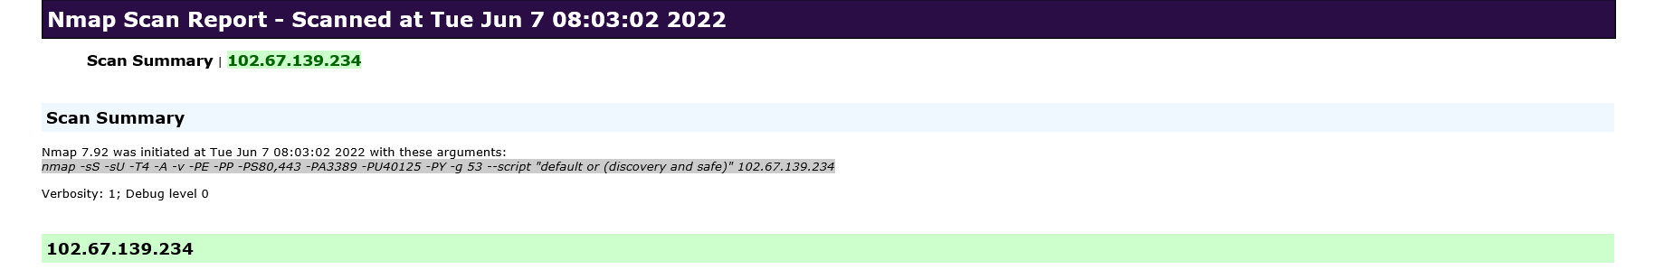

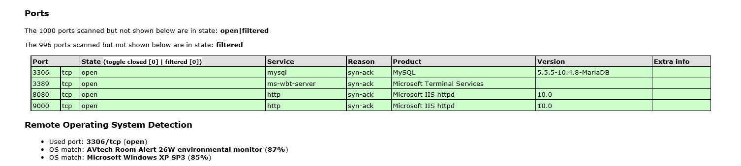

We Recommend closing RDP (3389) or either of the following perform RDP is Accessed

- VPN with Certicate (not username and password combination)
- Configure Local Firewall to only accept RDP connections from known source address
- Install 2FA i.e. Google Authenticator.

Web Application Testing

Exploiting vulnerabilities such as SQLi, XSS, CSRF, authentication flaws.

Database Exploitation

Testing where access is available to identify misconfigurations and vulnerabilities.

Active Directory

Testing for weak domain policies and credential storage flaws.
Example of Active Directory Bruce Force:

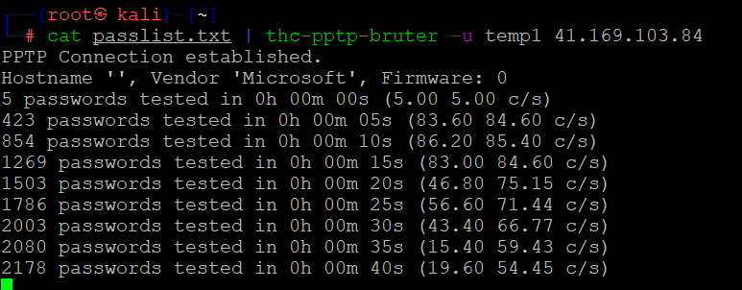

Administrator:500:aad3b435b51404eeaad3b435b51404ee:07c19e98f0ee02e10fce023c82d43c4d:

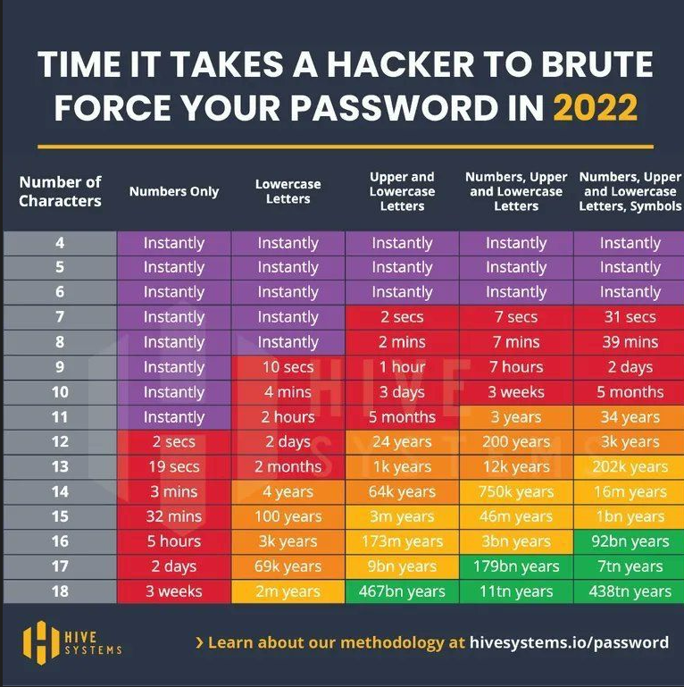

Wireless Network

Assessing AP security, encryption strength, and misconfigurations

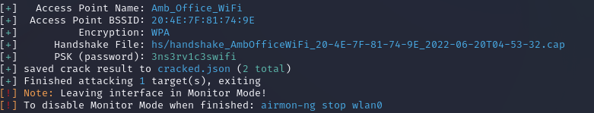

REPORTING AND REMEDIATION DELIVERABLES

Deliverables:
• Executive Summary (non-technical)
• Full Technical Report with CVSS, PoC evidence (screenshots, pcaps, logs)
• Phishing campaign metrics and user-level reports (confidential)
• FortiGate Resilience Report
• Wi-Fi Security Report
• Prioritized remediation roadmap and guidance
• 60–90 minute remediation workshop
• Optional retest report (on request)

COSTING AND COMMERCIALS

Blended rate: ZAR 1,500 per hour. Below is a sample costing for the 7-day engagement. VAT excluded.
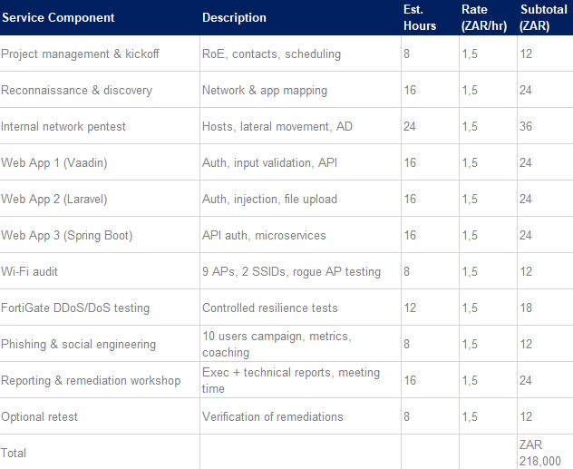

Risk Analysis for Cyber Penetration Testing Proposal

Objective

The objective of this risk analysis is to identify potential risks associated with conducting the penetration testing project for the client. This ensures that stakeholders understand the possible impacts and likelihood of risks, and supports decision-making, preparation, and mitigation strategies.

Risk Identification

- Unauthorized Access – Testing activities may uncover pathways that could unintentionally expose sensitive systems or data.
- Service Disruption – Testing of endpoints, firewalls, and network devices could inadvertently cause temporary service interruptions, degraded performance, or system crashes.
- Data Integrity & Loss – Vulnerability exploitation or testing may result in unintended data corruption or temporary unavailability if backups are not validated.
- Regulatory & Compliance Risks – Testing activities must align with applicable regulations (e.g., data protection, financial compliance) to avoid legal or reputational issues.
- False Positives & Negatives – Automated scanning may generate false results, leading to either wasted remediation effort or overlooked vulnerabilities.
- Critical System Dependencies – Testing backup/recovery systems, authentication, and databases introduces risks if these systems are not isolated or if dependencies are not properly managed.
- Reporting Sensitivity – Handling of test results and reporting may create risks of exposure if findings are not shared securely.

Risk Assessment

Risk | Likelihood | Impact
Unauthorized Access | Medium | High
Service Disruption | Medium | High
Data Integrity & Loss | Low | Medium
Regulatory & Compliance | High | High
False Positives/Negatives | Medium | Medium
Critical System Dependencies | Medium | High
Reporting Sensitivity | Low | Medium

Risk Mitigation

- Only in-scope systems are tested by implementing a formal pre-test checklist and client confirmation of approved assets. Exclusions (such as social engineering and DoS testing) will be documented and validated with the client before commencement.
- Access Controls – Limit test access to authorized personnel and follow strict authentication and approval processes.
- Change & Maintenance Windows – Conduct testing during pre-approved maintenance/testing windows to reduce operational disruption.
- Data Backup & Recovery Validation – Ensure all critical systems and databases have validated backups before testing begins.
- Compliance Alignment – Obtain written approvals and ensure testing is aligned with relevant compliance frameworks (e.g., PCI-DSS for payments, POPIA where applicable).
- Verification of Findings – Manually validate automated scanner results to minimize false positives/negatives.
- Controlled Exploitation – Exploitation activities will be carefully scoped and limited to avoid uncontrolled damage to production systems.
- Secure Reporting & Communication – All findings, evidence, and reports will be encrypted and shared only via approved secure communication channels.
- Change Control & Authorization: All testing will proceed only after written approval from designated client stakeholders. Any changes to scope will require updated authorization.
- Confidentiality & Data Handling: Sensitive client information will be protected under NDA and securely managed throughout the project lifecycle.
- Monitoring & Escalation: Testing activities will be monitored continuously. Any issue with potential service disruption will be escalated immediately to the client.
- Evidence Retention: Logs, screenshots, and other evidence will be securely retained for reporting and securely destroyed post-project where required by policy.

Risk Monitoring and Review

- Risks will be continuously monitored throughout the penetration testing project.
- Mitigation strategies will be reviewed at each project phase.
- Post-engagement, a lessons-learned review will be conducted to identify residual risks and refine future testing approaches.

TERMS & CONDITIONS

Confidentiality

All information obtained during the engagement will be treated as strictly confidential and used solely for the purpose of conducting the penetration testing and vulnerability assessments.

Client Responsibilities

- The client is responsible for providing accurate and up-to-date system information, credentials, and documentation required for testing.
- The client must ensure that all necessary internal approvals, authorizations, and change controls are in place before commencement.

Testing Boundaries

- Only systems, applications, and networks explicitly listed in the agreed Scope of Work will be tested.
- Any additional systems identified during testing will require written approval before being included.

Liability

While every effort is made to minimize risk, penetration testing carries inherent risks of service disruption or system instability. Sautech will not be held liable for unintentional downtime, data corruption, or business impact unless due to proven negligence.

Compliance

Testing activities will align with relevant laws and regulations. The client must ensure that third-party approvals (e.g., cloud providers, hosted environments) are obtained if applicable.

Reporting and Ownership

All findings, reports, and recommendations remain the intellectual property of Sautech until full payment is received. Upon payment, the client receives full rights to use the reports internally.

Payment Terms

Payment is due as per the agreed commercial terms outlined in the cost analysis section. Delays in payment may result in withholding of reports or deliverables.

Validity

This proposal is valid for a period of 30 (thirty) days from the date of issue.

References / APENDICES

Sautech has delivered successful penetration testing engagements across financial services, banking, and payment providers in Southern Africa. Client-specific references and case study references below:

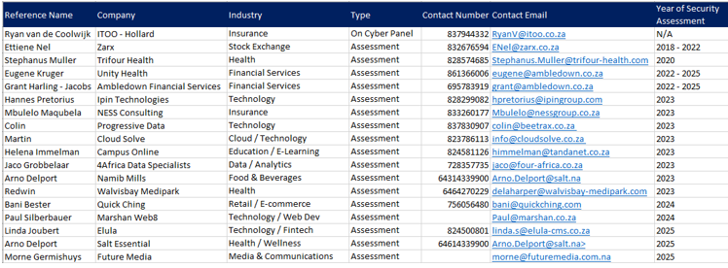

CONCLUSION
Sautech is committed to assisting Labournet in strengthening its cybersecurity posture by identifying vulnerabilities, assessing real-world risks, and providing actionable recommendations for remediation.
This proposal outlines a structured and controlled penetration testing approach aligned with industry best practices, with clearly defined objectives, scope, methodologies, risk safeguards, and deliverables, the project will not only uncover vulnerabilities but also enable the client to build a sustainable and secure IT environment.
We look forward to partnering with Labournet to proactively address current and emerging cyber threats, ensuring resilience, compliance, and protection of critical business operations.

AUTHORISATION

This proposal has been prepared and approved by Sautech (Pty) Ltd for submission to Labournet.

24th October 2025 – Krugersdorp, Gauteng, South-Africa

______________________________
Riaan van Jaarsveld
Director
Sautech (Pty) Ltd

